Conveyer woven netting
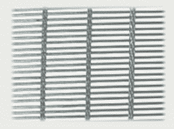 | Material - stainless steel wire. Conveyer woven netting is suitable for using as belt in belt conveyers for drying different materials and foodstuff.

Aperture, mm | Diameter of strand and weft, mm | Number of strand wires in warp | Diameter of wire in strand, mm | Width of cloth, mm | Weight in kgs per 1 sq.m.
24/2 | 0,72/1,5 | 4 | 0,30х4 | 1250-2960 | 4,42
15/1,5 | 0,53/1 | 4 | 0,22х4 | 2000 | 3,51
12/1 | 0,72/0,9 | 2 | 0,30х4 | 1250-2000 | 3,114
11/3,6 | 0,72/1,2 | 4 | 0,30х4 | 2000-3060 | 2,605
3,3/1,6 | 0,92/1,2 | 3 | 0,30х7 | 2000-3100 | 5,175
3/1 | 0,72/0,7 | 1 | 0,30х4 | 1250-2000 | 2,634
0,8/0,8 | 0,53/0,6 | 1 | 0,22х4 | 1250-2000 | 2,778

